###### Deliverable 1. Login as the named user (not root!) and attempt to ping google.com, ad01 and fw01.

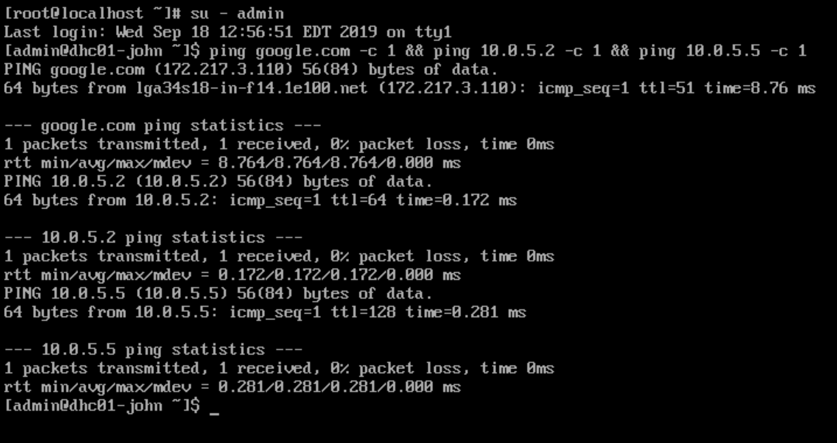

###### Deliverable 2. Using WKS01, Provide a screenshot showing the successful ping using dhcp01's hostname only (leave off yourname.local).

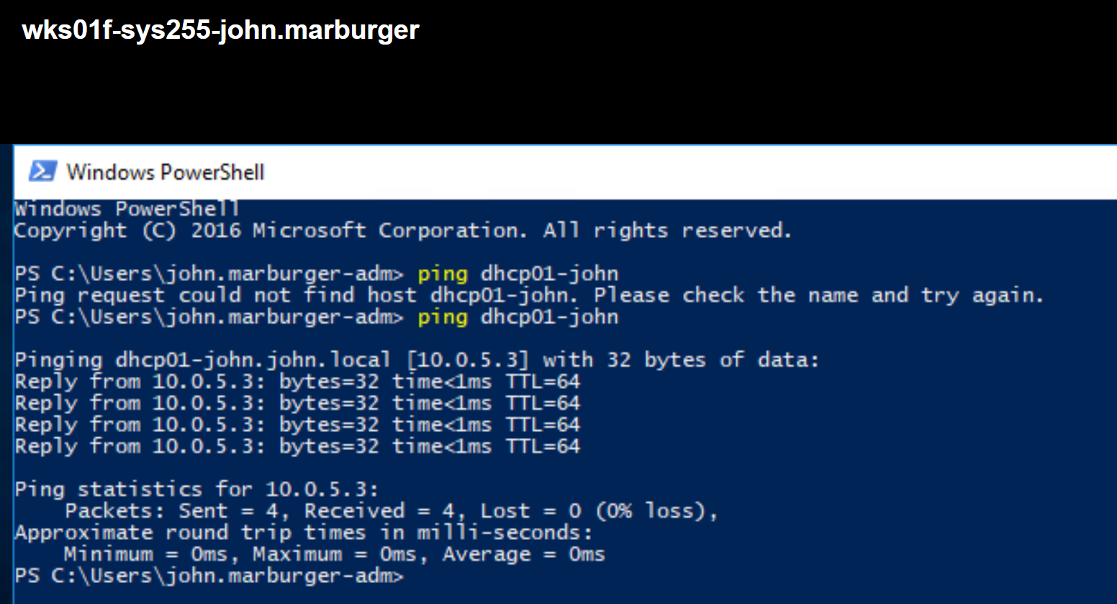

###### Deliverable 3. Provide a screenshot that shows a successful ssh session as your named linux user.

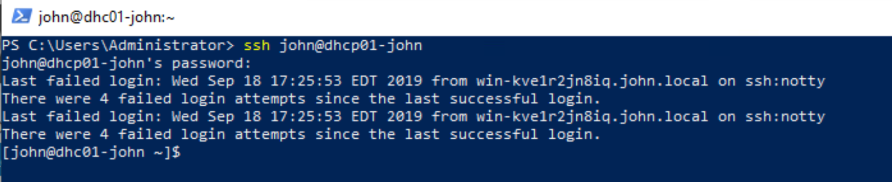

Deliverable 4: Provide the first 10 commands recorded in your history file:

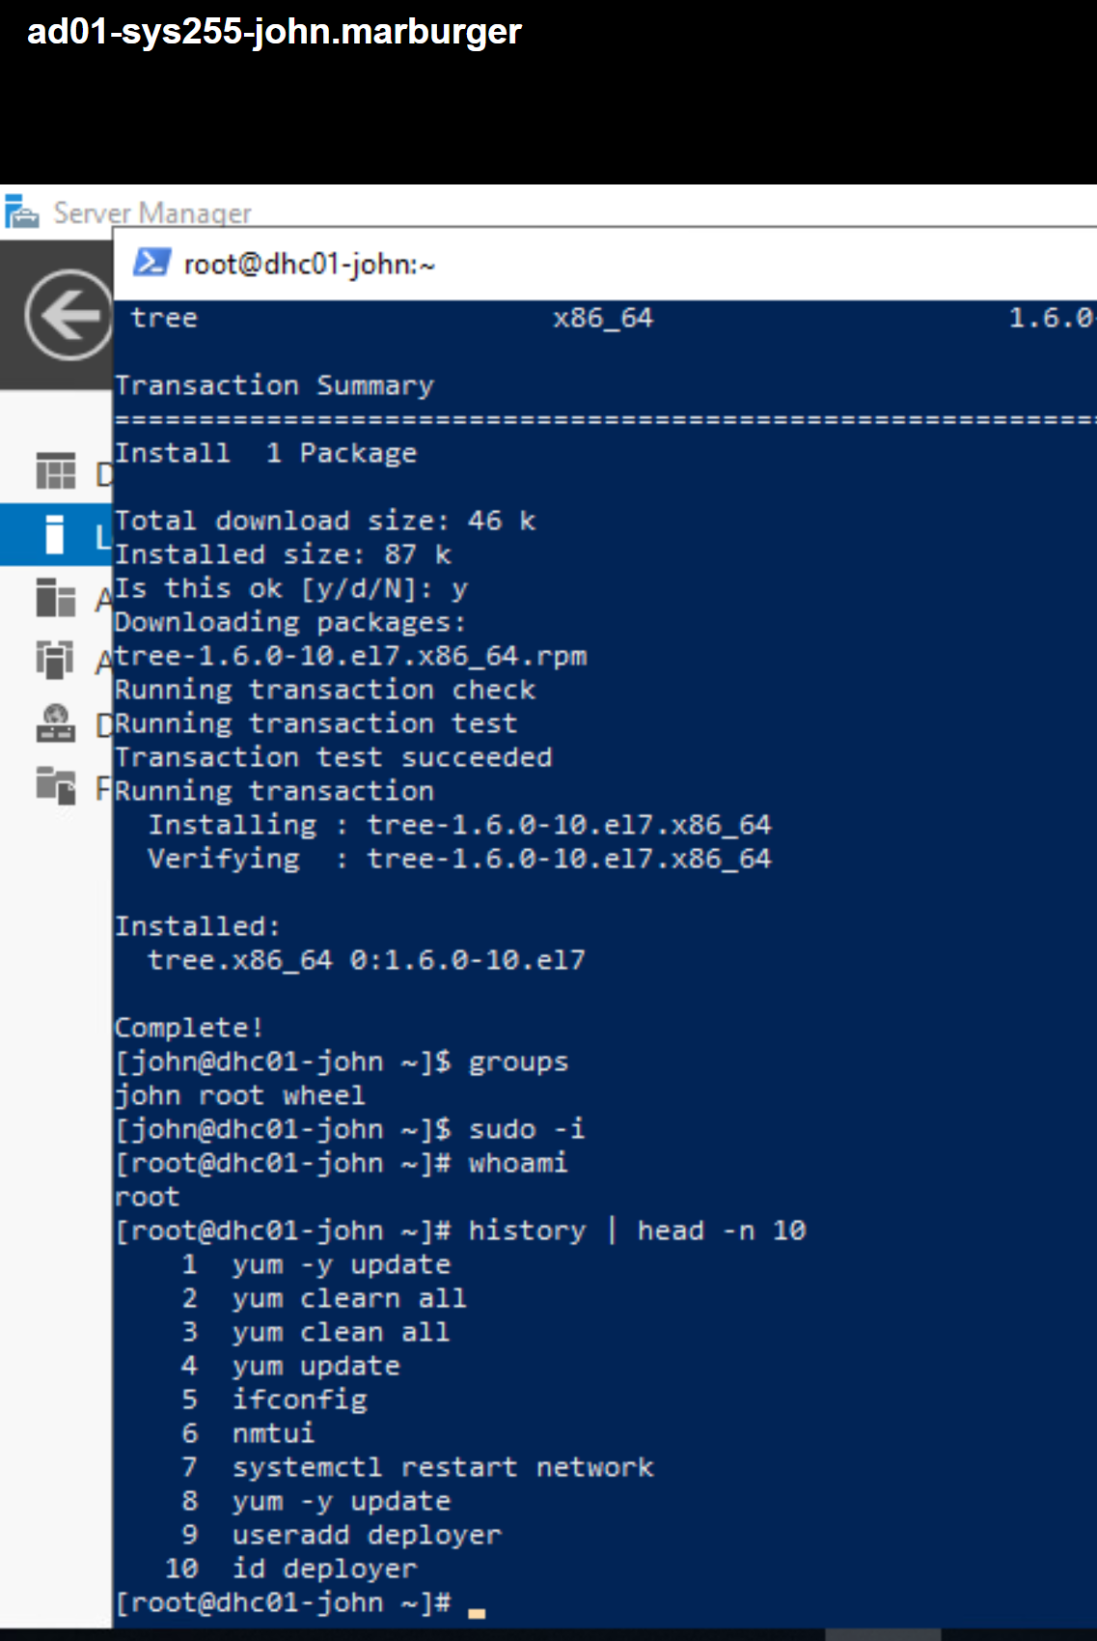

###### Deliverable 5. This is a two part question.

###### What security implications does this file represent. List at least one pro and one con.

-one pro is that it keeps track of all commands run

-one con is that this can be manipulated or deleted

###### What command is used to clear bash history?

-according to the **man history** pages, using “history -c” works